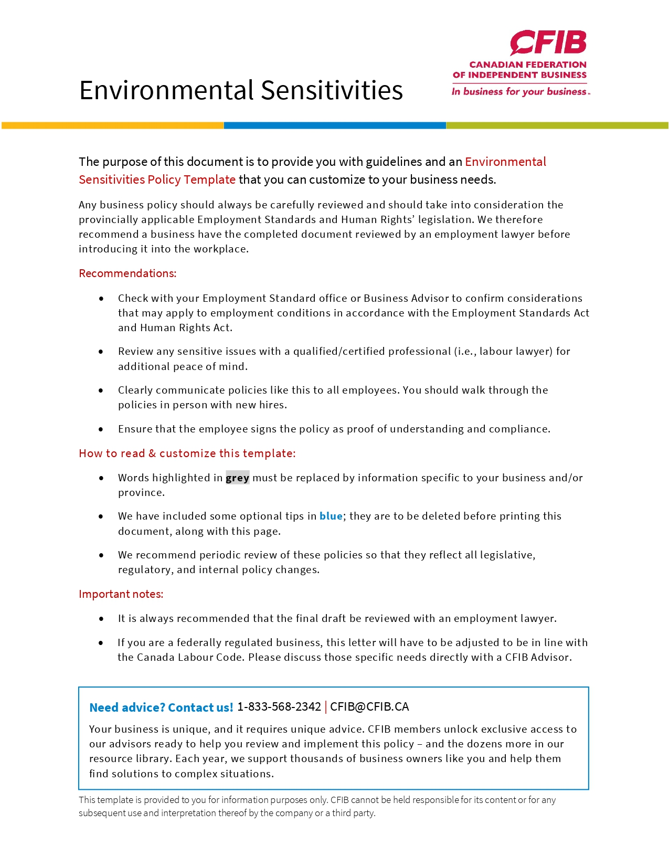
ENVIRONMENTAL SENSITIVITIES
WORKPLACE INFORMATION
Employee odours, whether natural or artificial, are a common and complex workplace problem. Telling an employee that their scent (whether from fragrance, smoke, or body odour) is not acceptable in the workplace can be a difficult conversation for both the employee and the company. We recommend approaching these issues with sensitivity, but also in a straightforward manner.

Scented products
Employers are required to provide a workplace that is healthy and safe. Environmental sensitivities can be a chronic condition whereby a person has symptoms when exposed to certain chemicals or other environmental agents. The symptoms may range in severity from mild to debilitating. This medical condition is a disability and those living with environmental sensitivities are entitled to the protection of the Canadian Human Rights Act, which prohibits discrimination on the basis of disability. The Canadian Human Rights Commission will receive any inquiry and process any complaint from any person who believes that he/she has been discriminated against because of an environmental sensitivity. Like others with a disability, those with environmental sensitivities are required by law to be accommodated.

When scented products have been blamed for adversely affecting a person's health, some or all of the following symptoms are reported:

- headaches
- dizziness, light-headedness
- nausea
- fatigue
- weakness
- insomnia
- numbness
- upper respiratory symptoms
- shortness of breath
- skin irritation
- malaise
- confusion
- difficulty with concentration

Allergic and asthmatic patients, as well as those with other conditions, report that certain odours, even in the smallest amounts, can trigger an attack. The severity of these symptoms can vary. Some people report mild irritation while others are incapacitated and/or must give up many 'normal' activities in order to avoid exposure (such as going to public places). As a consequence, some patients report feelings of depression or anxiety.

Scents are included in a very large range of products including:

- shampoos and conditioners
- hairsprays
- deodorants
- colognes and aftershaves
- fragrances and perfumes
- lotions and creams
- potpourri
industrial and household chemicals

- soaps
- cosmetics
- air fresheners and deodorizers
- oils
- candles
- diapers
- some types of garbage bags

It is important to remember some products which claim to be 'scent free' may have only masked the scent by use of an additional chemical. Be sure to research the product carefully if using these products around those who are sensitive.

Residual odours (Body Odour, Smoke)
Please note: Human Rights Considerations
  - Although body odour is not a prohibited ground of discrimination under Human Rights and is not considered a disability in itself, it can be viewed as caused by a disability. In such cases, under the Human Rights Code, the employer would have a duty to accommodate the employee up to a point of undue hardship.
  - Due to the legal implications and potential financial ramifications of this issue, do not assume or inquire the cause of the odour and remember that you are not allowed to ask your employee about any medical condition they may have.
  - Should an employer discipline an employee or terminate their employment based on their body odour, the employee could make a human rights claim and establish their body odour is resulting from a disability.

When it comes to body odour and other residual odours that are considered unpleasant, such as smoke, keep these best practices in mind:

- Wait for a pattern to emerge. In other words, don’t address this issue with an employee the first
or second time you notice poor hygiene or bad body odour, or unpleasant smelling clothes.
- Ask to meet with the employee privately to address the issue confidentially and directly.
- Start with a soft approach to make the employee feel comfortable and inform him/her that you have made some observation recently relating to their personal hygiene and/or odour, and although their employment is absolutely not at risk, it is important to resolve the problem as it may impact the rest of the workplace. You could say something along the lines of: “I’m sure you’re not aware of it, but thought you’d like to know that I’m noticing an odd odour. I think it might be your…... (fill in the blank)”
- The general rule when having this discussion is that you (1) name the issue (2) give an example
(3) describe it objectively (4) clarify why it’s important (5) explain why you want to resolve it (6) invite the person to respond.
- Don’t say that several co-workers have raised the issue with management as it may create a
negative atmosphere in the workplace. However, you may have to admit you’re not alone in your
observations in the event that the employee accuses you of bullying, etc.
- Protect the employee. It is vital to ensure that other employees are not harassing or ostracizing the employee. If co-workers are doing so, the employees should be reprimanded and disciplined.
- Make recommendations to the employee such as bringing a change of clothes, changing to a scent-free deodorant, etc.
- In the event that the body odour is the cause of a disability, you would want to offer accommodation based on your employee’s physician’s recommendation.

Before you implement a policy
  - Conduct an assessment to determine the extent of the issue and if an environmental sensitivities policy is appropriate to your workplace. This may be as a result of employee complaints, observed behaviours, or customer concerns.
  - Address any concerns the employees raise openly and honestly.

  - Reinforce the idea that this policy is being implemented as a result of medical concerns - not merely because of a dislike for a certain smell.
  - Make it clear that the policy applies to everyone (including visitors, patients, etc.).
  - This policy is meant to address any odours that make the workplace an uncomfortable or unhealthy environment to work in. Do not limit the policy to perfumes and colognes; consider other environmental odours and residual odours such as smoke, body odour and other strong-smelling scents.
  - Involve the health and safety committee and get management commitment from the beginning.
  - Be sure that all employees have been fully informed of the policy and that they know what they have to do before the policy becomes effective. There is an agreement at the end of this document.
  - Educate the employees. You may choose to include brochures or flyers in payroll envelopes, publish articles in a company newsletter, or give presentations.
  - Post a list of approved unscented products and where they are available locally.
  - Review all material safety data sheets/safety data sheets (MSDSs/SDSs) for the products currently used and for those you are considering using. Make sure that the ingredients are acceptable. Remember that some products which claim to be scent-free may be using additional chemicals to mask smells instead of truly being unscented.
  - Conduct trials in limited areas before purchasing large quantities of a product.
  - Post notices that waxing, shampooing, painting, or spraying (etc.) will be conducted one week beforehand so that affected personnel can make arrangements or have their duties modified during that time.
  - Put the policy statement notice on all appointment cards, stationery, room booking notices, employment postings, etc.
  - Decide on wording for 'Scent Free' signs and where the signs will be posted (see an example below).
  - Let everyone know that the policy will be reviewed and can be changed because of experience or new knowledge.

Employers and employees share responsibilities for making sure work environments are healthy and safe. Encourage everyone in your workplace to be accountable for health and safety.

Please remove these three information pages before completing and/or distributing your policy.

ENVIRONMENTAL SENSITIVITIES POLICY FOR

NAME OF BUSINESS

Due to the health concerns arising from exposure to scented products, name of business has instituted this policy to provide an environment that limits odours that are disruptive or offensive to others or may exacerbate allergies. This policy applies to all employees and visitors.

The use of scented products will not be allowed within the workplace at any time. This includes odours as a result of, but not limited to:

    - shampoos and conditioners
    - hairsprays
    - deodorants
    - colognes and aftershaves
    - fragrances and perfumes
    - lotions and creams
    - soaps
    - cosmetics
    - air fresheners and deodorizers
    - candles

To support this policy all materials used by name of business for cleaning will be scent-free. A list of locally available scent-free products is available from the health and safety office/representative.

Employees are reminded that name of business encourages courtesy measures to limit the impact of residual odours (such as smoke, body odour etc.) in the workplace through use of unscented hand sanitizer, brushing of teeth, washing of hands, keeping a change of clothes at work (if applicable) etc.

Management reserves the right to review and change this policy based on experience or new knowledge.

Date
Name of business reserves the right to amend this policy at any time.

AGREEMENT – NAME OF BUSINESS’S ENVIRONMENTAL SENSITIVITIES POLICY

We are pleased to welcome you to the name of business team.

This is a good opportunity to provide you with a copy of the Environmental Sensitivities Workplace Policy, which will help you get off to a good start. The objective is to give you an overview of the business and the human resources practices of our company, and to ensure the efficiency of our operations and the harmony of our team.

All employees, whether seasoned or new, may occasionally need to consult the Environmental Sensitivities Workplace Policy. This document is intended as an easy-to-use reference tool containing the answers to your main concerns. Should any of your questions remain unanswered, please feel free to contact name and telephone number.

All the name of business policies are evolving documents that may be adapted as appropriate to reflect cultural and organizational changes as well as the modifications that are constantly being made to government regulations. We name of business are committed to maintaining open and transparent communication with all employees and will provide updated policies (where applicable) in a timely manner.

ACKNOWLEDGEMENT OF HAVING READ AND UNDERSTOOD THE ENVIRONMENTAL SENSITIVITIES WORKPLACE POLICY

I, , attest that I have read the Environmental Sensitivities Workplace Policy and its various components, including the following:
• List any additional addendums (if applicable)

I acknowledge having received all the relevant information that I need in order to have a good understanding of the content and scope of this policy.

Employee – Print Name
Employee – Signature |  | Date
Employer – Print Name
Employer – Signature |  | Date

The original copy is given to the employee and the employer retains a photocopy for their files.

SAMPLE WORDING FOR WORKPLACE SIGNAGE

People who work at name of business are sensitive to various scented products. We ask for everyone's cooperation in our efforts to accommodate their health concerns.

In response to health concerns, name of business has developed a Scent-Free Environment. Scented products such as hair products, perfume, after shave and deodorant can trigger reactions such as respiratory distress and headaches. Staff and visitors are asked to not use these products when reporting to this office.

Name of business is a Scent-Free environment. Please do not use scented products while at work and while visiting with us.

We thank you in advance for your cooperation.

